**APPROACH:**

// Find next node using next pointer

struct Node *temp = node_ptr->next;

// Copy data of next node to this node

node_ptr->data = temp->data;

// Unlink next node

node_ptr->next = temp->next;

// Delete next node

free(temp);

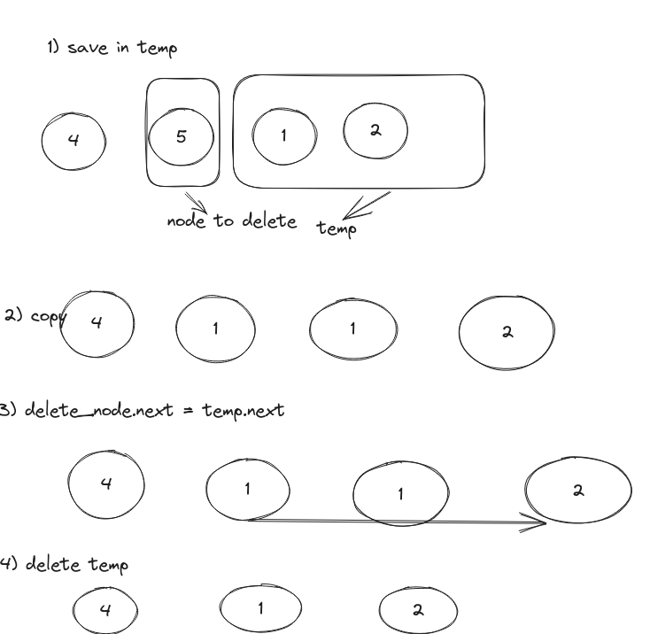

CODE:  
 # save next nodes in temp

temp = node.next

# copy value of next node in the node to be deleted

node.val = temp.val

# update node to be deleted's pointer to next of next node(temp.next)

node.next = temp.next

temp.next = None

Time O(1)

Space O(1)